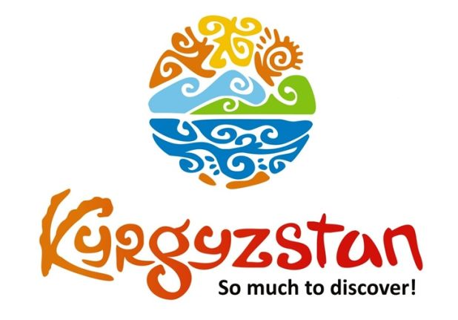**One week Kyrgyz Patterns Tour**

Country: **Kyrgyzstan**

Period: **middle of June – September**

**Days: 7 / Nights: 6**

Organizing any complexity of tours to Issyk-Kul, Son-Kul, around Kyrgyzstan and Central Asia. We guarantee you high quality of service and individual approach!

This tour is perfect if you are interested in nature of Kyrgyzstan and in its culture/traditions/history at the same time.

After a short stay in Bishkek you'll travel around Issyk-Kul Lake(1608 m), the second largest alpine lake in the world!

Additionally, you will visit Burana Tower – an important site on the Silk Road, the town of Karakol, the flower valley Jeti-Oguz and Kochkor village which is famous for its felt production.

**Day 1: Manas Airport – Bishkek**

Upon arrival to airport meet with a local guide/driver and transfer to city.

City tour of capital’s main highlights: Ala-Too Main Square, Open Air Art Gallery where visitors can see the paintings of local artists, Oak Park, Panfilov Park, walk through the Erkindik Boulevard where one can meet Kyrgyz urban people of all ages. Additionally, a visit to the Youth Alley where the Statue of Manas, the founder of the Kyrgyz nation, is located.

Dinner at a yurt-styled restaurant at Supara Ethno-Complex (traditional Kyrgyz cuisine).

National folklore show with Manaschi chanting the epic Manas is followed during the dinner.

Arrive back to Bishkek, overnight at hotel. Check-in to hotel at/after 14:00pm. *Meals: lunch, dinner*

**Day 2: Bishkek – Kochkor village (230 km/4 h)**

After breakfast, depart to Kochkor village. Spend a day with Kyrgyz family to experience daily life of local people who will welcome you into their home. Visit Altyn-Kol (“Golden Hands”) - a cooperative shop of women from the surrounding villages where they sell handmade felt products.

Learn more about Kyrgyz traditions and culture: assist the family with bread baking, milking cows and cooking meals.

In the afternoon, watch demonstration of felt craft making and take part in the procedure.

Traditional lunch and dinner at the house with a family.

Free time for rest in the evening.

*Meals: breakfast, lunch dinner*

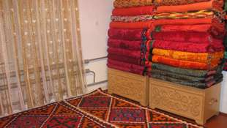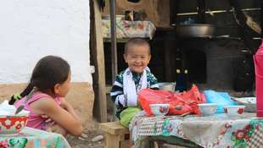

**Day 3: Kochkor – Jeti-Oguz (385 km/6 h)**

After breakfast depart to Jeti-Oguz Valley alongside the southern shore of Issyk-Kul Lake.

Visit Manjyly-Ata and have a lunch at a yurt camp.

Before heading to Jeti-Oguz, visit Fairytale Valley/Canyon

The canyon was named after its bizarre rocky landscape, which for many years has been transformed by wind into various sculptures and formations. Some structures have been named for their similarity to well-known objects. For example, one set of ridges in the canyon is called the "The Chinese Wall" due to its similarity to the Great Wall of China. Visitors can also find what appear to be statues of a hippopotamus, snakes, dragons, sleeping giants and even whole castles. Not only do the rocks have different shapes, but also various colors.

Upon arrival, accommodation at yurt camps.

*Meals: breakfast, lunch, dinner*

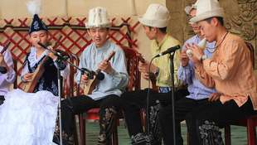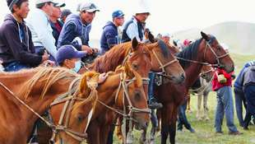

**Day 4: Jeti-Oguz – Karakol (40 km/1.5 h)**

Some free time in the morning for walks in the valley. Taste national beverage Kymyz (fermented mares milk) and experience the real nomads life. After lunch at a yurt camp depart to Karakol. On the way, visit famous red rocks known as "Seven Bulls" and "Broken Heart" (easy walking and trekking).

Upon arrival to Karakol town, have a city tour: visit beautiful Russian Church made entirely of wood (built without nails), Dungan Mosque (Dungan’s are ethnic minority of Muslim Chinese, moved from the West of China) and Kupecheskiy Proezd street that resembles 19th century old Russian village. Further, visit one-village-one-product local shop for handmade souvenir products. This shop is run by the association of local women who produce a wide range of products from wild berry jams, handicrafts, herbal soaps and other souvenirs, all using products and materials found in Issyk-Kul region. Dinner and overnight at guesthouse.

*Meals: breakfast, lunch, dinner*

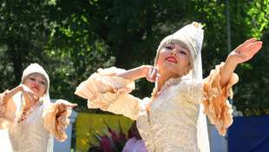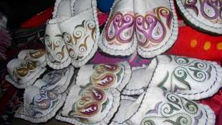

**Day 5: Karakol – Chon-Kemin (340 km/ 6 h)**

After breakfast, depart to Chon-Kemin Valley via the Northern shore of Issyk-Kul lake.

Visit open-air Petroglyphs Museum and Rukh-Ordo Cultural Complex in Cholpon-Ata town.

Upon arrival to Kalmak-Ashuu village, accommodation at Ashu guesthouse.

Traditional homemade dinner at the guesthouse.

Free time for rest and/or easy walking tour around the village.

*Meals: breakfast, lunch, dinner*

**Day 6: Chon-Kemin – Bishkek (135 km/3 h)**

After breakfast, morning excursion in Kalmak-Ashuu Gorge.

Horseback riding is available upon request.

After lunch depart for Bishkek with en-route stops at Burana Historical Complex, Burana Minaret, ruins of ancient city of Balasagyn, open air museum. Upon arrival to Bishkek, check in to a hotel and free time.

Farewell dinner at a local restaurant.

*Meals: breakfast, lunch, dinner*

**Day 7: Bishkek – Manas Airport**

After breakfast, transfer to the Airport for the departure flight.

Check-out from the hotel before/at 12:00 pm.

*Meals: breakfast*

| **GROUP SIZE** | **PRICE IN USD/PER PERSON** |
| --- | --- |
| 2 | 1 480 USD |
| 3-4 | 1300 USD |
| 5-6 | 1085 USD |
| 7-8 | 990 USD |
| Supplementary for single stay | 185 USD |

| **PRICE INCLUDES** |  |
| --- | --- |
| Twin based accommodation | Bishkek - 3* hotel (2 o/n)  Kochkor - home stay (1 o/n) Jeti-Ogyz - yurt camp (1 o/n) Karakol - guest house (1 o/n) Chon-Kemin - guest house (1 o/n) |
| *Note:* | *Single accommodation is not available at home stays and at yurt camps,   2-6 pax share one room/yurt.   Conditions are basic, but decent and clean.   Facilities (toilet and shower) are located in the corridor for shared use -home stay; outside the yurt for shared use - yurt camp* |
| Transportation | Comfortable vehicle with a/c |
| Guide services (Eng/Russ) | Included |
| Meals | Full board: from lunch on Day-1 till breakfast on Day-8 |
| Entrance fees | Included |
| Bottled water | 1 liter person/per day |

| **PRICE EXCLUDES** |
| --- |
| International flights |
| Visa to Kyrgyzstan/visa support/passport registration (if required) |
| Early check-in, late check-out from hotel |
| Personal expences |
| Horseback riding in Chon-Kemin |

**Contact information:**

[www.travelscruiser.com](http://www.travelscruiser.com)

Phone (24/7): +996 …………., +996 ……….

E-mail: [info@travelscruiser.com](mailto:info@travelscruiser.com)